4-8 Main Question (สำหรับแสดงข้อสอบ)

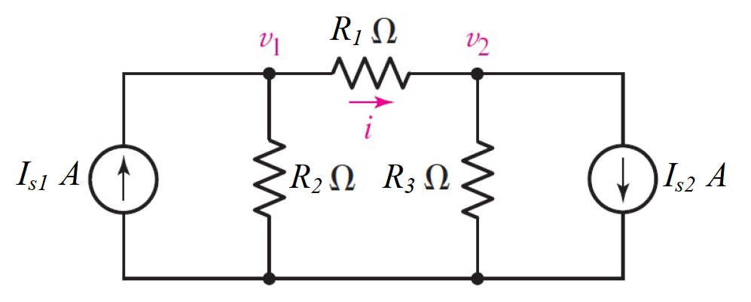

Given *IS*1 = 5 A, *IS*2 = 4 A, *R*1 = 5 Ω, *R*2 = 1 Ω, *R*3 = 2 Ω.

Find

Variables (สำหรับเขียนโค้ดเพื่อหาคำตอบ)

Random variables

IS1 = {5:10}; IS2 = {1:5};

R1 = {1:5}; R2 = {1:5}; R3 = {1:5};

Global variables

#IS1 = 5; IS2 = 4; R1 = 5; R2 = 1; R3 = 2;

G11 = 1/R1+1/R2; G12 = -1/R1; G22 = 1/R3+1/R1;

I1 = IS1; I2 = IS2;

D = G11\*G22-G12\*G12;

D1 = I1\*G22+I2\*G12;

D2 = -I1\*G12-I2\*G11;

V1 = D1/D; V2 = D2/D;

Part (กรอกคำตอบ)

1. *v*1 = V1 = 3.375 V

2. *v*2 = V2 = -4.75 V

4-10 Main Question (สำหรับแสดงข้อสอบ)

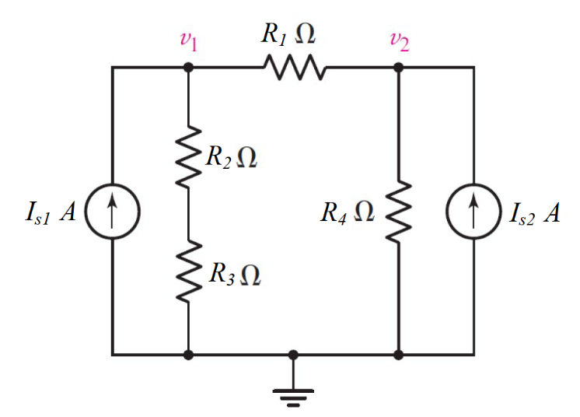

Given *IS*1 = 2 A, *IS*2 = 15 A, *R*1 = 1 Ω, *R*2 = 5 Ω, *R*3 = 4 Ω, *R*4 = 2 Ω.

Find

Variables (สำหรับเขียนโค้ดเพื่อหาคำตอบ)

Random variables

IS1 = {1:5}; IS2 = {10:15};

R1 = {1:5}; R2 = {1:5}; R3 = {1:5}; R4 = {1:5};

Global variables

#IS1 = 2; IS2 = 15; R1 = 1; R2 = 5; R3 = 4; R4 = 2;

G11 = 1/R1+1/(R2+R3); G12 = -1/R1; G22 = 1/R1+1/R4;

I1 = IS1; I2 = IS2;

D = G11\*G22-G12\*G12;

D1 = I1\*G22-I2\*G12;

D2 = G11\*I2-G12\*I1;

V1 = D1/D; V2 = D2/D;

Part (กรอกคำตอบ)

1. *v*1 = V1 = 27 V

2. *v*2 = V2 = 28 V

4-11 Main Question (สำหรับแสดงข้อสอบ)

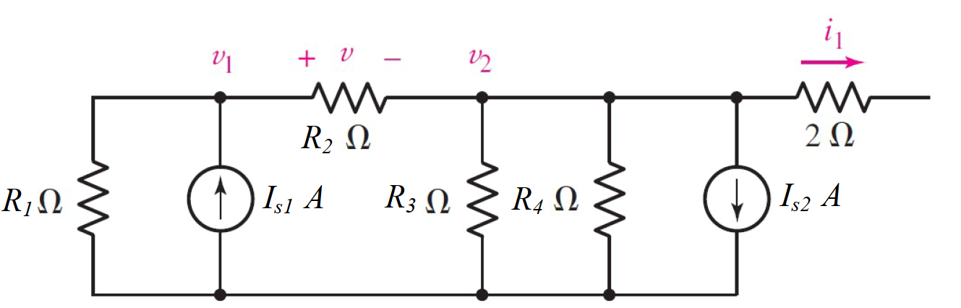

Given *IS*1 = 2 A, *IS*2 = 4 A, *R*1 = 3 Ω, *R*2 = 1 Ω, *R*3 = 6 Ω, *R*4 = 6 Ω.

Find

Variables (สำหรับเขียนโค้ดเพื่อหาคำตอบ)

Random variables

IS1 = {1:5}; IS2 = {1:5};

R1 = {1:5}; R2 = {1:5}; R3 = {5:10}; R4 = {5:10};

Global variables

#IS1 = 2; IS2 = 4; R1 = 3; R2 = 1; R3 = 6; R4 = 6;

G11 = 1/R1+1/R2; G12 = -1/R2; G22 = 1/R2+1/R3+1/R4;

I1 = IS1; I2 = IS2;

D = G11\*G22-G12\*G12;

D1 = I1\*G22+I2\*G12;

D2 = -I1\*G12-I2\*G11;

V1 = D1/D; V2 = D2/D;

Part (กรอกคำตอบ)

1. *v*1 = V1 = -1.714 V

2. *v*2 = V2 = -4.285 V

4-13 Main Question (สำหรับแสดงข้อสอบ)

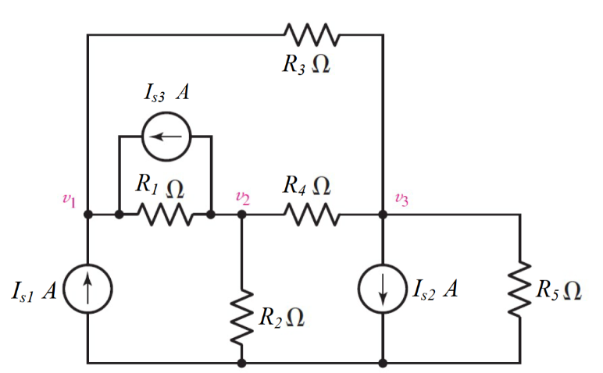

Given *IS*1 = 8 A, *IS*2 = 5 A, *IS*3 = 4 A, *R*1 = 3 Ω, *R*2 = 5 Ω, *R*3 = 3 Ω., *R*4 = 1 Ω., *R*5 = 7 Ω.

Find

Variables (สำหรับเขียนโค้ดเพื่อหาคำตอบ)

Random variables

IS1 = {5:10}; IS2 = {5:10}; IS3 = {1:5};

R1 = {1:5}; R2 = {1:5}; R3 = {1:5}; R4 = {1:5}; R5 = {5:10};

Global variables

#IS1 = 8; IS2 = 5; IS3 = 4;

#R1 = 3; R2 = 5; R3 = 3; R4 = 1; R5 = 7;

G11 = 1/R1+1/R3; G12 = -1/R1; G13 = -1/R3;

G21 = G12; G22 = 1/R1+1/R2+1/R4; G23 = -1/R4;

G31 = G13; G32 = G23; G33 = 1/R3+1/R4+1/R5;

I1 = IS1+IS3; I2 =-IS3; I3 = -IS2;

D = G11\*G22\*G33+G12\*G23\*G31+G13\*G21\*G32-G31\*G22\*G13-G32\*G23\*G11-G33\*G21\*G12;

D1 = I1\*G22\*G33+G12\*G23\*I3+G13\*I2\*G32-I3\*G22\*G13-G32\*G23\*I1-G33\*I2\*G12;

D2 = G11\*I2\*G33+I1\*G23\*G31+G13\*G21\*I3-G31\*I2\*G13-I3\*G23\*G11-G33\*G21\*I1;

D3 = G11\*G22\*I3+G12\*I2\*G31+I1\*G21\*G32-G31\*G22\*I1-G32\*I2\*G11-I3\*G21\*G12;

V1 = D1/D; V2 = D2/D; V3 = D3/D;

Part (กรอกคำตอบ)

1. *v*1 = V1 = 26.73 V

2. *v*2 = V2 = 8.833 V

3. *v*3 = V3 = 8.633 V

4.17 Main Question (สำหรับแสดงข้อสอบ)

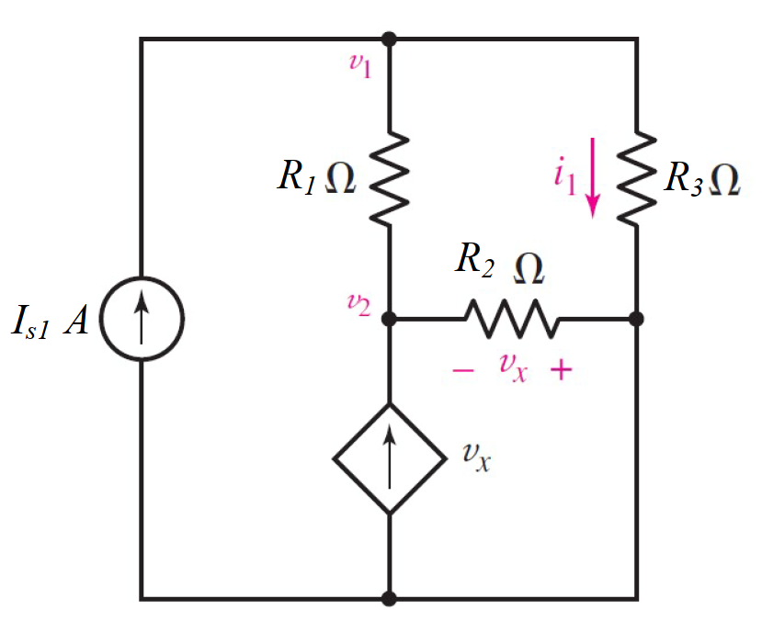

Given *IS*1 = 1 A, *R*1 = 5 Ω, *R*2 = 3 Ω, *R*3 = 2 Ω.

Find

Variables (สำหรับเขียนโค้ดเพื่อหาคำตอบ)

Random variables

IS1 = {1:5};

R1 = {1:5}; R2 = {1:5}; R3 = {1:5};

Global variables

#IS1 = 1; R1 = 5; R2 = 3; R3 = 2;

G11 = 1/R1+1/R3; G12 = -1/R1; G22 = 1/R1+1/R2+1;

D = G11\*G22-G12\*G12;

D1 = IS1\*G22;

D2 = -G12\*IS1;

V1 = D1/D; V2 = D2/D;

I1=V1/R3;

Part (กรอกคำตอบ)

1. *v*1 = V1 = 1.484 V

2. *v*2 = V2 = 0.1935 V

3. *i*1 = I1 = 0.742 A